**Scrutiny of Invitation Card Sales Data**

***Mrs.B.Vidhya MCA., M.Phil., (PhD) 1*,ARAWIND.S & ASWIN.S 3***

1 Assistant professor, Department of Computer Science with Data Analytics,

Sri Ramakrishna College of Arts & Science, Coimbatore, Tamilnadu, India.

2 Department of Computer Science with Data Analytics,

Sri Ramakrishna College of Arts & Science, Coimbatore, Tamilnadu, India.

3 Department of Computer Science with Data Analytics,

Sri Ramakrishna College of Arts & Science, Coimbatore, Tamilnadu, India.

***Abstract***

*This study delves into the analysis of card sales performance to facilitate informed decision-making within*

*the context of a card-selling business. Key objectives include identifying the card type contributing*

*the highest revenue, pinpointing the card with the lowest sales volume, calculating the average price*

*of invitation cards, determining the card with the lowest profit margin, forecasting sales for the upcoming*

*30 days, recognizing repeatedly sold card types, identifying high-profit margin cards, and assessing the*

*correlation between price and quantity sold. Through rigorous analysis, this study aims to optimize sales*

*strategies and enhance profitability while gaining insights into market dynamics. By addressing these*

*objectives, businesses can adapt their approaches to maximize efficiency and effectiveness in the*

*competitive marketplace.*

***Keywords:*** *Card sales, performance analysis, revenue generation, sales volume, pricing evaluation, profit margin, sales forecasting, market dynamics, optimization, profitability, card types, correlation analysis, sales revenue.*

\****Author for Correspondence*** E-mail: natrajprintsshanmugam@yahoo.com, Tel: +91 7010231832

**INTRODUCTION**

Data is generally raw pieces of information that simply includes basic numbers or text. Data Analytics is a process for translating basic facts and figures into specific actions by examining raw data. The purpose is to help people and businesses make better decisions and achieve greater success [11].

**A. Approaches of Data Analytics**

1. Descriptive Analytics: This approach involves analysing past data to identify patterns, trends, and relationships. Descriptive analytics provides insights into what has happened in the past and is used to summarize and describe historical data.

Example: Patient data can be summarized to identify common health issues. For example, most of the people get the flu from October to June.

2. Diagnostic Analytics: It is used to identify the root cause of a problem or issue.

Example: In case of cyber threat, it is used to identify the source of a security breach and prevent future attacks.

3. Predictive Analytics: It involves using statistical models and algorithms to predict future trends and to identify opportunities and risks.

Example: In healthcare, predictive analytics can be used to identify patients at risk of developing a particular disease.

4. Prescriptive Analytics: This approach involves using algorithms to identify the best course of action to take based on the predicted outcomes of different scenarios.

Example: Using google Ref.maps for directions during peak hours. [5]

Each of these approaches has its own strengths and weaknesses, and the choice of approach depends on the specific business problem or question being addressed. By combining these approaches, organizations can gain a more comprehensive understanding of their data and makes more informed decisions.

**B. Steps of Data Analytics**

The process of data analytics consists of the following steps [12] [6]:

1. Defining the question: The first step in any data analytics process is to define the objective. In data analytics jargon, this is sometimes called the ‘problem statement’. Defining the objective means coming up with a hypothesis and figuring out how to test it.

2. Collecting the data: After defining objective next step is to collect and segregate data. The data might be quantitative (numeric) data like sales figures or qualitative (descriptive) data like customer reviews.

All data fit into one of the three categories[6]:

(I) First party data: The data that is directly collected from customers by us or the company. Example: Customer satisfaction surveys.

(II) Second party data: It is the primary data of other organizations. This might be available directly from the company or through a private marketplace. Example: Website, App.

(III) Third party data: The data that has been collected and aggregated from numerous sources by a third-party organization. Example: Gartner.

3. Cleaning the data: This can be done by removing major errors, duplicates, outliers and removing unwanted data points. Then bringing a structure to the data and filling the major gaps.

4. Analysing the data: It can be done through descriptive, diagnostic, predictive and prescriptive analysis.

5. Sharing results: The final step of data analytics is to share the insights with the world. The insights must be 100% clear and unambiguous along with the evidence. Honest communication is the most important part of the process.

6. Embracing failures: The last step is to embrace failures. Data analysis is inherently chaotic, and mistakes occur. So, embracing failure is often the critical first step on the road to success.

7. Summary: Till this all the main steps of the data analytics process. These core steps can be amended, reordered and reused accordingly.

**C. Applications of Data Analytics**

Data analytics can have variety of applications in different fields [13] [7].

1. Customer care centre:

Analytics in customer care centre helps agents improve their performance by providing objective, insights into their customer interactions. Analytics helps in sales increase by identifying patterns in customer behaviour and providing agents with the information they need to engage with callers on a more personal-level and maintain high rates as result. It helps in increasing customer’s satisfaction and track agents process in real time.

2. Security: It uses data analytics to identify previous, ongoing and future occurrences of crime or security attacks.

3. Risk Management: It is a major concern of insurance sector. Data analytics provides insurance firms with information on claims data, actuarial data, and risk data.

4. Customer Interactions: It is about insurance. Different populations prefer different modes of communication. Using demographic data and feedback, insurers may improve customer experience based on customer behaviour and insights.

5. Education – To improve curriculum data can be collected from students and those data help in improving resource allocation and long-term management decisions.

6. Marketing and data advertising – Marketers employ data analytics to understand their customers and increase conversation rates. Advertising specialists employ analytics to learn about the audience’s interests, dislikes, age, gender etc. To achieve high conversation rates, professionals use data analytics to uncover patterns and provide content for long-term engagement.

7. Travel – Data analytics here can observe data from social media to demonstrate the desires and preferences of different customers.

**II. OVERVIEW OF THE PROBLEM**

**A. Problem Study**

To analyse card performance, that can determine the card with the highest revenue and the lowest sales. Calculating the average price of invitation cards helps evaluate pricing. Identifying low profit margins involves comparing profit percentages. The day with the highest card sales can be found by analyse quantities sold. Cards sold repeatedly have multiple occurrences with varying quantities. High-profit margin cards can be identified through comparison. Correlation between price and quantity sold indicates their relationship. Average daily sales revenue per card can be calculated for overall performance evaluation.

**B. Challenges of the Study**

**Challenges:**

The study faces challenges such as obtaining comprehensive and reliable sales data, navigating the complexity of large datasets, and identifying meaningful patterns amidst variability. Accurately forecasting sales amidst market fluctuations and translating analytical insights into actionable strategies also present significant hurdles. Addressing these challenges requires advanced analytical tools, expertise in data analysis, and strategic decision-making abilities..

**Objectives:**

1. To find type of card that generated the highest revenue.

2. To find type of card that had the lowest sales volume.

3. To find the average price of invitation cards sold at the shop.

4. To find type of card had the lowest profit margin.

5. Predict the sales forecasting for next 30 days.

6. To find which card sold repeatedly

7. To find type of card has a high profit margin.

8. To find the average daily sales revenue for each type of card.

**III. DATA PREPARATION**

**A. Data Collection**

The data is analyzed for the month of January to June 2023. After analyzing the data, it is found that the data consists of 295 datas and had eight fields that contain name, cost, selling price, profit, profit margin, quantity sold and revenue

The data set is collected by approaching a printing press which sales invitation cards also which was located in Ismail street ,Townhall, Coimbatore the name of the shop was sun wedding cards this shop has no webpage.

**B. Data Method**

Exploratory data analysis (EDA) is used by data scientists to analyze and investigate data sets and summarize their main characteristics, often employing data visualization methods. It helps determine how best to manipulate data sources to get the answers you need, making it easier for data scientists to discover patterns, spot anomalies, test a hypothesis, or check assumptions.

The main purpose of EDA is to help look at data before making any assumptions. It can help identify obvious errors, as well as better understand patterns within the data, detect outliers or anomalous events.

**Types of Exploratory Data Analysis:**

1. Univariate non-graphical – It is a simplest form of data analysis, where the data being analysed consists of just one variable. It doesn’t deal with causes or relationships as it is a single variable. The main purpose is to describe the data and find patterns that exist with it.

2. Univariate graphical – Non-graphical methods don’t provide a full picture of the data. In such cases graphical methods are required. Graphical like histograms and box plots can be used.

3. Multivariate nongraphical – It arises from more than one variable. It generally shows the relationship between two or more variables of the data through statistics.

4. Multivariate graphical – It uses graphics to display relationships between two or more sets of data. [9]

In this data set the pivot table, pivot charts (from insert) and forecast sheet (from data) is used for analyzing. Pivot table was created by Pito Salas in 1986. This concept came from Lotus Software (Lotus Development Corporation). This data set falls under Multivariate nongraphical (forecast sheet) and Univariate graphical (all the other analysis falls under this category). [10].

**C. Purpose of data**

The analysis encompasses several key objectives. Firstly, it aims to identify the card that generated the highest revenue by summing up individual card revenues and selecting the one with the highest total. Secondly, it seeks to pinpoint the card with the lowest sales volume by comparing quantities sold for each card in the dataset. Additionally, the study endeavors to compute the average price of invitation cards sold at the shop by aggregating prices and dividing by the total number of cards sold. Moreover, it aims to identify cards with low profit margins by calculating profit margins for each card and comparing them across the dataset. Furthermore, the analysis involves predicting and forecasting sales for the next thirty days to provide insights into future performance and profitability. It also aims to identify cards that are repeatedly sold by examining the frequency of their occurrence in sales data. Additionally, the study aims to determine cards with high profit margins by comparing profit percentages across different cards. Lastly, it seeks to calculate the average daily sales revenue per card by summing up daily revenues and dividing by the total number of days. Through these objectives, the analysis aims to provide comprehensive insights into card sales performance and profitability.

**IV. METHODOLOGY**

**A. Descriptive Analysis Approach**

1.which card made highest revenue?

Step 01: The column name and revenue taken as input

Step 02: The columns are analysed and processed using pivot table

Step 03: Using pivot table value field setting select sum to proceed highest sold card

Step 04: From the analysis the Sivam card has highest sold in the shop for the total revenue of 47,600 INR.

2. Lowest sold card in the shop?

Step 01: The column name and revenue taken as input

Step 02: The columns are analysed and processed using pivot table

Step 03: Using pivot table value field setting select min to proceed lowest sold card

Step 04: From the analysis the Vairam card has lowest sold in the shop for the total revenue of 11,800 INR.

3. What is the average price of invitation cards sold at the shop?

Step 01: The column name and revenue taken as input.

Step 02: The columns are analysed and processed using pivot table.

Step 03: Using pivot table value field setting select average to find the price of the sold card.

Step 04: From the analysis the average price of the card sold at the shop is 7.5 INR.

4. Which card has lowest profit margin?

Step 01: The column name and profit margin taken as input

Step 02: The columns are analysed and processed using pivot table

Step 03: Using pivot table value field setting select min to find the lowest profit margin of the card Step 04: From the analysis the Sivam card has lowest profit margin.

5.Predict the sales forecasting for next 30 days.

Step 01: select the entire dataset

Step 02: In data tools select forecasting sheet. to forecast data for the next 30 days.

Step 03: From the analysis the forecasting prediction for the next 30 days was predicted.

6. which card sold repeatedly?

Step 01: The name of the card as taken and input

Step 02: By using python3 jupyter notebook and pandas used for visualization

Step 03: By using python3 jupyter notebook it gives the result that Sivam card has repeatedly sold

7. which card have highest profit margin?

Step 01: The name of the card and profit margin taken as input

Step 02:By using python3 jupyter notebook and pandas used for visualization

Step 03: By using python3 jupyter notebook it gives the result as Vairam card had high profit margin with 37%

8. calculate average daily sales revenue by card?

Step 01: The name of the card and revenue column taken as input

Step 02: By using python3 jupyter notebook and pandas used for visualization

Step 03: By using python3 jupyter notebook it gives the result that Sivam card with 24.2% of sales

**B. Statistical analysis Approach**

It focuses on making predictions on a larger data set based on a sample of those data. From the data of Invitation Card Sales of January to June 2023 the data for the next 30 days is that is, from 08/06/2023 to 08/07/2023 the profit margin is predicted.



45%

40%

35%

30%

25%

20%

15%

10%

5%

0%

Profit Margin (%)

Forecast(Profit Margin (%))

Lower Confidence Bound(Profit Margin (%)) Upper Confidence Bound(Profit Margin (%))

Fig 4.2(c) Output of forecast sheet

Fig 1.0 Output of the forecast

Step 01: select the entire dataset

Step 02: In data tools select forecasting sheet to forecast data for the next 30 days.

Step 03: From the analysis the forecasting prediction for the next 30 days was predicted.

**V. RESULTS, FINDING INSIGHTS AND DISCUSSION**

1. 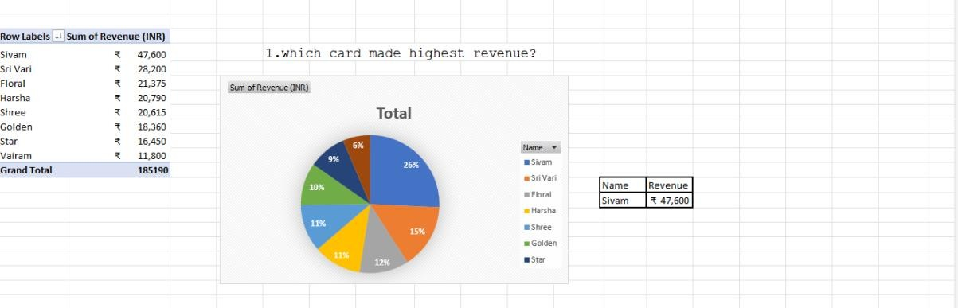**Which card made highest revenue?**

Fig no:2

The above result shows that which card made highest revenue in past six months the card which made high revenue is Sivam which made revenue of ₹47,000

## Which is lowest sold card?

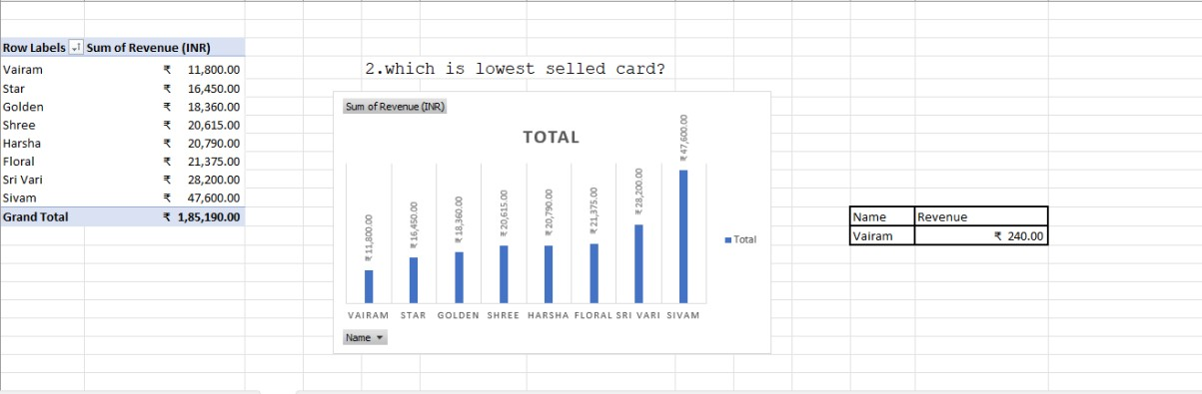 Fig no:3

The above pivot table gave the result as lowest sold card that is Vairam which is lowest sold and made revenue of ₹1100

## What is the average price of invitation cards sold at the shop?

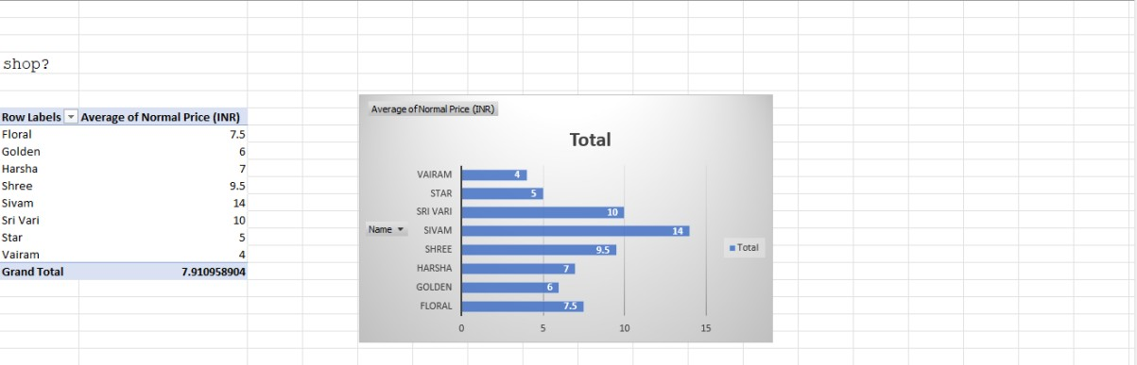

Fig no:4

The above pivot chart give the result of average price of the invitation cards which had sold in the shop for six months that is 7.910958904

## What card have lowest profit margin?

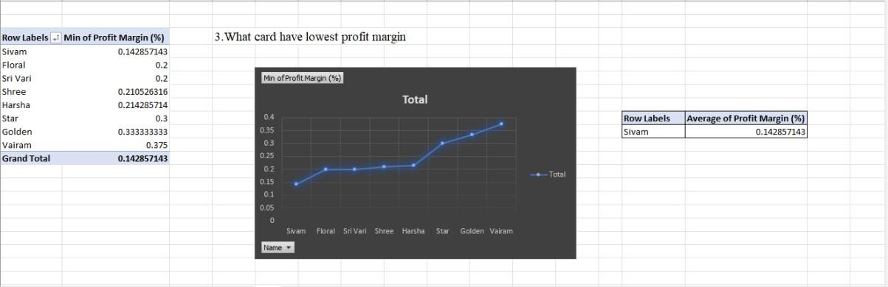

Fig no:5

The above result shows the cards that have low profit margin which is indicated below the low profit margin column but lowest among these items Sivam which had 0.142857143

## Predict the sales forcasting for next 30 days

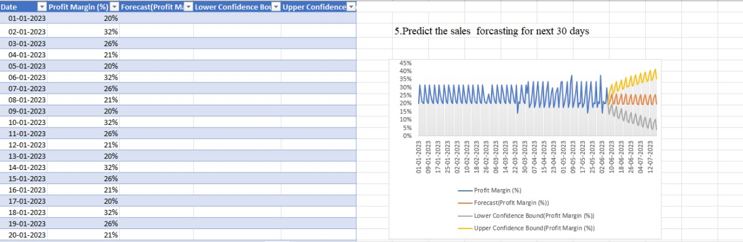

Fig no:6

By using forecasting sheet plugin in data section the sales forecasting for next 30 days was predicted. This shows the sales prediction for next 30 days in the shop .This analysis helps to predict the future sales of the enterise.so the enterprise can prepare the stock quantity based on the analysis.

## RESULTS - PYTHON:

**6.Which card sold repeatedly?**

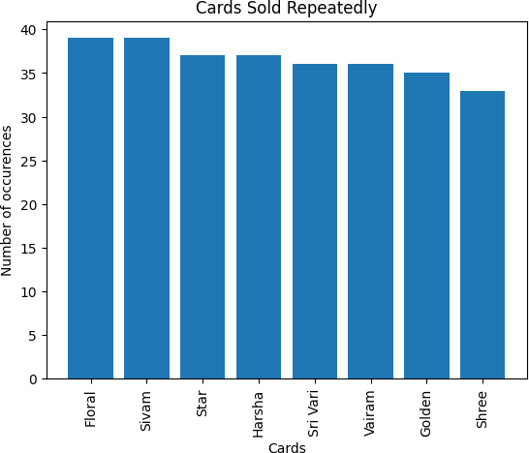

Fig no:7

The above result shows the output by a bar plot showing that the repeatedly sold card is floral and Sivam

**7.Which card have high profit margin?**

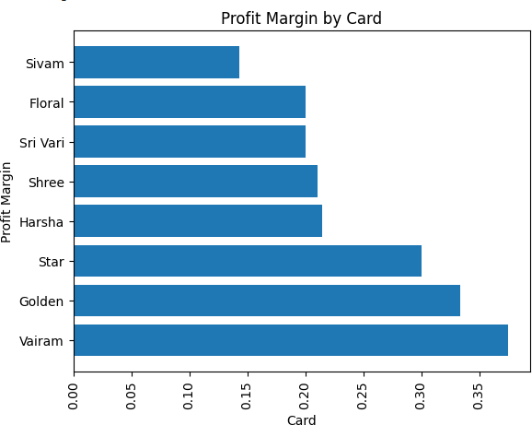

Fig no:8

The above result shows the output of cards in a barh plotting that have high profit margin cards highest of the items is Vair

## 8.calculate average daily sales revenue by card

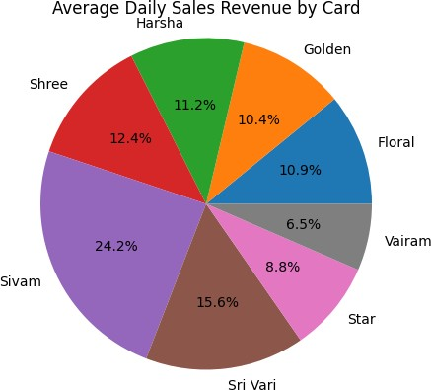

Fig no:9

The above result shown in pie chard displays average sales revenue by card the highest of these cards is Sivam that had 24.2% of average sales revenue.

The overall analysis found are:

* The analysis of invitation card sales utilized Microsoft Excel and Python 3 Jupyter Notebook for distinct purposes: Excel for generating a comprehensive sales report and Python for data visualization and deeper insights.
* In the Microsoft Excel analysis spanning January 2023 to June 8, 2023, 293 sales data points were recorded, accumulating ₹185,190 in revenue.
* Peak sales were observed on April 2, 2023, with the Sivam Card generating the highest revenue at ₹47,000, constituting 26% of total sales.
* Conversely, the Vairam Card yielded the lowest revenue at ₹11,000, accounting for only 6.7% of total sales.
* The average price of invitation cards stood at ₹7.5, with an average profit margin of 14.28%, attributed to a narrow difference between cost and selling price.
* In the Python 3 Jupyter Notebook analysis, the focus shifted to visualizing data and extracting deeper insights.
* The Sivam Card emerged as the consistently most frequently sold card, attributed to its moderate price of ₹12, aligning with customer preferences.
* The Vairam Card was identified to have the highest profit margin.
* Calculations of average daily sales revealed the sustained dominance of the Sivam Card in terms of sales volume.
* Integrating both tools provided a holistic understanding of invitation card sales dynamics, encompassing revenue generation, profit margins, and sales trends.

**Hardware and Software Requirements used are:**

HARDWARE: The system used in this project is Windows 11. It has 11th Gen Intel(R) Core (TM) i3-1115G4 @ 3.00GHz 3.00 GHz processor with 8.00GB RAM and 64-bit operating system, x64-based processor system type.

SOFTWARE:

The software utilized in this summer internship project comprises Microsoft Office Excel, specifically the 2021 version, along with Python Jupyter Notebook. In Microsoft Excel, the analysis primarily relies on pivot tables and forecast sheets. Pivot tables facilitate both descriptive and statistical analysis, offering an interactive method to summarize extensive datasets efficiently. Additionally, pivot charts are employed to visualize data through graphical diagrams. Furthermore, forecast sheets are utilized to predict future values based on historical data. Python Jupyter Notebook is also utilized for data analysis and visualization, providing a versatile platform for exploring datasets, conducting statistical analysis, and generating visualizations to extract insights from the data. This integration of Excel and Python Jupyter Notebook allows for a comprehensive and multi-faceted analysis approach, combining the strengths of both tools to derive valuable insights from the data.

**VI. CONCLUSION**

In conclusion, the utilization of both Microsoft Excel and Python 3 Jupyter Notebook in the analyses of invitation card sales has yielded significant insights, as previously discussed. Through Microsoft Excel, we were able to conduct thorough analyses covering key aspects such as revenue, pricing, and profit margins. Pivot tables and forecast sheets facilitated descriptive and statistical analyses, allowing for a comprehensive understanding of sales trends over the specified period.

Moreover, Python 3 Jupyter Notebook provided a dynamic platform for deeper exploration of the data, particularly in understanding customer preferences and identifying patterns that might have been overlooked initially. For instance, we discovered that the Sivam Card consistently dominated sales, possibly due to its moderate pricing strategy. Additionally, Python enabled us to calculate and visualize profit margins, providing crucial insights into the financial performance of each card type.

Overall, these analyses have illuminated various dimensions of invitation card sales, including revenue generation, pricing dynamics, customer preferences, and profit margins. Armed with these insights, stakeholders can make informed decisions when formulating future sales strategies, optimizing pricing structures, and selecting product offerings to enhance profitability and customer satisfaction.

In summary, the integration of Microsoft Excel and Python 3 Jupyter Notebook has proven to be instrumental in providing comprehensive insights into invitation card sales performance, ultimately empowering informed decision-making for the organization's future endeavors.

**REFERENCES**

1. [https://www-edureka-co.cdn.ampproject.org/v/s/www.edureka.co/blog/what-is-](https://www-edureka-co.cdn.ampproject.org/v/s/www.edureka.co/blog/what-is-data) [data](https://www-edureka-co.cdn.ampproject.org/v/s/www.edureka.co/blog/what-is-data)-
2. [Towards Data Science](https://towardsdatascience.com/)
3. <https://www.analyticsvidhya.com/blog/2022/04/exploratory-data-analysis-eda-> [in-python/](https://www.analyticsvidhya.com/blog/2022/04/exploratory-data-analysis-eda-in-python/)
4. <https://u-next.com/blogs/business-analytics/applications-of-data-analytics/>